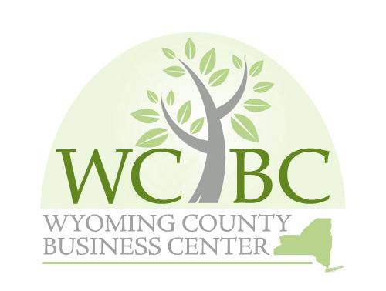
Wyoming County Business Center, Inc. Annual Board Meeting Agenda
March 7, 2025 at 10:00 a.m. at the Wyoming County Ag & Business Center
2nd Floor Conference Room

Roll call to establish quorum.

- Administrative
  - Review/approve minutes from November 6, 2024
  - Review/approve financial report for November-December 2024 and January-February 2025
  - Review/approve WCBC Mission Statement

Act on Governance Committee Recommendations

Approve Governance Committee Members Appointments

Approve Finance and Audit Committee Members Appointments

Approve Board Officers Appointments

Approve, Adopt and Re-adopt Governance Policies

Act on Finance/Audit Committee recommendations
  - Approve the 2024 Audit Report
  - Approve annual MOU with the IDA for administration of the WCBC for $30,000
  - Approve annual $5,000 for Invest Buffalo Niagara
  - Approve/Re-adopt Finance/Audit Policies
  - Approve/Re-adopt Investment Policy
  - Approve WCBC Investment Report
- Action Items
- Review and Approve 2024 Annual Report

- Program Updates
  - Micro Loan Program
  - Wyoming County Rapid Start Loan Program
  - Fast Track Program
  - Business Accelerator Program
  - Business Mentorship Program

Other Business

- Next Meeting: TBD

Adjournment

