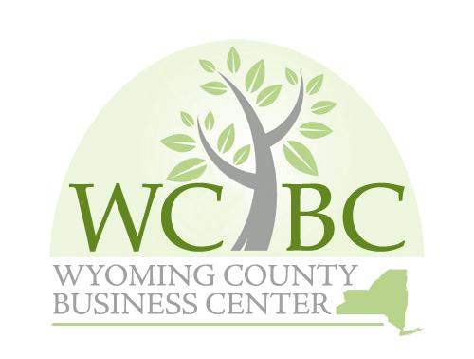
Wyoming County Business Center, Inc.
Annual Governance Committee, March 7, 2025, 10:00 a.m.

AGENDA

- Roll call to establish quorum

- Administrative

A. Review and approve Governance Committee Minutes from March 6, 2024

- Recommendations to the Board
- Appointment of Governance Committee Members

- Appointment of Finance and Audit Committee Members

- Appointment of Officers to the WCBC Board – recommend slate of

Officers for the Board

D. Review, Adopt and Re-adopt Governance Policies
- Procurement Policy

- Acquisition of Real Property Policy

- Disposition of Real Property Guidelines

- Conflict of Interest Policy- Re-adopt

- Adjourn Governance Committee Meeting

