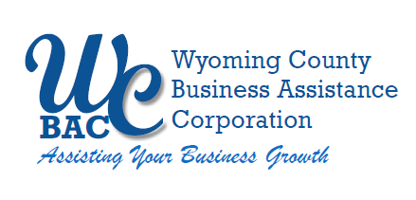

WYOMING COUNTY BAC BOARD MEETING
Thursday, January 11, 2024 @ 2:30 p.m.
Wyoming County Agriculture and Business Center
36 Center Street, 2nd Floor Conference Room
Warsaw, NY 14569

AGENDA

- Roll call to establish quorum.

Administrative

  - Review/approve Board Minutes from December 14, 2023
  - Review/approve Financial Reports for December 2023
  - Review and approve audit plan with Joseph Kehm from EFPR

- Action Items

  - Tentative loan request SilverLaken Estate (Glamping & Lodging)
  - Tentative loan request A & A Railroad (another grant anticipation note)
- Discussion Item

  - Microenterprise Grant Application to NYS Office of Community Renewal

- Other Business

- Next Meeting – February 8, 2024

6. Adjournment

