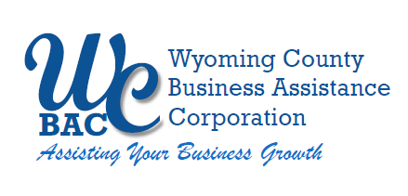

**WYOMING COUNTY BAC BOARD MEETING**

Thursday December 14, 2023 @ 2:30 p.m.

Wyoming County Agriculture and Business Center

36 Center Street, 2nd Floor Conference Room

Warsaw, NY 14569

**AGENDA**

1. **Roll call** to establish quorum.

## Administrative

* 1. Review/approve Board Minutes from September 21, 2023
  2. Review/approve Financial Reports for September-November 2023
  3. IDA Board Compliance Documents & Evaluation
  4. Review and approve amended Sexual Harassment Policy
  5. Set IDA Board Meeting Dates for 2024

1. **Discussion Items**
   1. Microenterprise Grant Application to NYS Office of Community Renewal
   2. Consider the adoption of a Diversity, Equity and Inclusion Policy
2. **Other Business** – New website presentation
3. **Next Meeting –** January 11, 2024

**6. Adjournment**