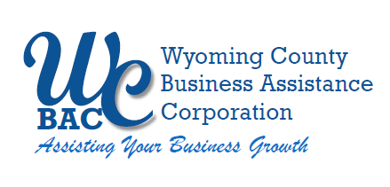

**WYOMING COUNTY BAC BOARD MEETING**

Thursday, January 16, 2025 @ 2:30 p.m.

Wyoming County Agriculture and Business Center

36 Center Street, 2nd Floor Conference Room

Warsaw, NY 14569

**AGENDA**

1. **Roll call** to establish quorum.

## Administrative

* 1. Review/approve Board Minutes from November 14, 2024
  2. Review/approve Financial Reports for November and December 2024
  3. Review and approve 2024 Audit Plan presented by Joseph Kehm from EFPR
  4. Set WCBAC Board Meeting Dates for 2025

1. **Action Items**

**The WCBAC’s Microenterprise Grant Committee is scheduled to meet On January 13, 2025 to review and make recommendations on 4 microenterprise grant applicants, those recommendations will be added in this section as an amendment to the WCBA Meeting Agenda for January 16th.**

1. **Other Business**
2. **Next Meeting –** February 13, 2025

**6. Adjournment**