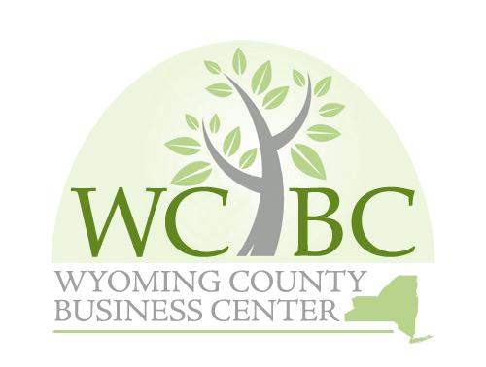
Wyoming County Business Center, Inc.
Annual Finance and Audit Committee March 7, 2025 at 10:00 a.m.

AGENDA

- Roll call to establish quorum.

Administrative

  - Review and approve Finance and Audit Committee Minutes from March 6, 2024
  - 2024 Audit Report-Presentation by Joe Kehm from EFPR Group

Recommendations to the Board

  - Approve the 2024 Audit Report
  - Authorize annual MOU with the IDA for administration of the WCBC at $30,000
  - Consider authorization of annual $5,000 investment in Invest Buffalo Niagara, a regional economic development partner of the WCBC.
  - Review/re-adopt Finance /Audit Policies
  - Investment Policy- Re-adopt Policy
  - Review and Approve WCBC Investment Report

Adjourn Finance/Audit Committee Meeting

