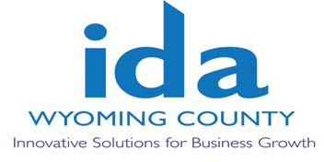
WYOMING COUNTY IDA BOARD MEETING
Thursday April 11, 2024 @ 2:30 p.m.
at the Wyoming County Agriculture and Business Center
36 Center Street, 2nd Floor Conference Room
Warsaw, NY 14569

AGENDA
- Roll call to establish quorum.

Administrative
  - Review/approve Board Minutes from March 14, 2024
  - Review/approve financial reports for March 2024

- Action Items
  - Sales tax extension request by Sunrise Court to renew the exemption for another year until 4/30/25 in order to fully complete the project.

Executive Director’s Report

Discussion Items
  - A request by an agricultural business to create the ability to offer tax exemption bond financing that can be potentially be used to finance 3rd party development and operation of manure digestors on our larger dairies that are expanding. It is assumed the most appropriate organization best suited to make this available is the Wyoming County Business Center, Inc. who will have this item up for discussion on their next meeting agenda.

  - WCIDA 50th Year Anniversary Discussion

Staff Compensation Discussion- Tabled at the March IDA Board Meeting

Other Business

- Next Meeting: May 9, 2024

Adjournment

