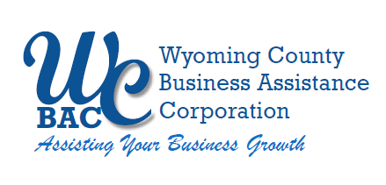

WYOMING COUNTY BAC BOARD MEETING
Thursday June 13, 2024 @ 2:30 p.m.
at the Wyoming County Agriculture and Business Center
36 Center Street, 2nd Floor Conference Room
Warsaw, NY 14569

AGENDA

- Roll call to establish quorum.

Administrative

  - Review/approve Board Minutes from April 11, 2024
  - Review/approve Financial Reports for April & May 2024
  - Review and renew MOU between the WCIDA & WCBAC for another five years for administrative services (the annual fee was $75,000 for the last five years).

- Action Item

  - Request by A & A Railroad to extend the current Grant Anticipation Note for a New NYS DOT Grant for continuation of building out replacement rail.

- Discussion Item

  - Update on implementation of the new Micro Enterprise Grant

- Other Business

- Next Meeting – July 11, 2024

7. Adjournment

