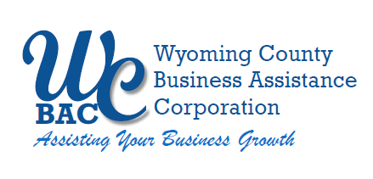

WYOMING COUNTY BAC BOARD MEETING
Thursday, April 11, 2024 @ 2:30 p.m.
Wyoming County Agriculture and Business Center
36 Center Street, 2nd Floor Conference Room
Warsaw, NY 14569

AGENDA

- Roll call to establish quorum.

Administrative

  - Review/approve Board Minutes from March 14, 2024
  - Review/approve Financial Reports for March 2024

- Action Items

  - Request by A & A Railroad to Extend the current Grant Anticipation Note for a New NYS DOT Grant for continuation of building out replacement rail.

  - Request by Amanda Osborn, owner of the Dell Collective, for a loan of $110,000 to renovate a vacant house acquired for the purpose of establishing a new Air BnB facility in Portageville. Amanda Osborn will present an overview of her business and need for the financing. Mark George will follow Ms. Osborn with an underwriting presentation of the loan.

  - Request by Andrew Aquado for a $200,000 loan to assist with the purchase of Montgomery’s Building Supply business in Warsaw and acquiring new inventory. Mr. Aquado will present an overview of his loan request and his plans. Mark George will follow up with an underwriting presentation on the loan.

- Other Business

- Next Meeting – May 9, 2024

6. Adjournment

