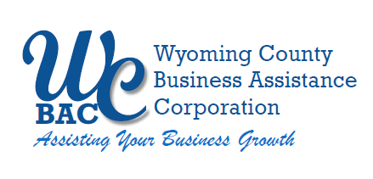

**FINANCE/AUDIT COMMITTEE MEETING**

**of the**

**WYOMING COUNTY BAC BOARD**

Immediately following the WCBAC’s Governance Committee Meeting

Thursday, September 11, 2025 @ 11:00 a.m. at Farmcraft Brewery, 567 Rt. 20A, Strykersville, NY

**AGENDA**

1. **Roll call** to establish quorum.
2. **Review and Approve Minutes**
   1. Review for approval the minutes from the September 12, 2024
3. **Recommendations to the Board**
4. Review/Recommend preliminary budget for 2026

1. Review/re-adopt Finance/Audit Policies
2. Investment Policy – re-adopt
3. Audit and Finance Committee Charter – re-adopt charter
4. **Adjourn Finance/Audit Committee Meeting**